**Performance of a Multi-Model Ensemble for the Simulation of Temperature Variability Over Ontario, Canada**

Aly Al Samoulya, Chanh Nien Luonga, Zhong Li b,\*, Spencer Smithc, and Maysara Ghaithd

aJoint first authors, Department of Civil Engineering, McMaster University, Hamilton, Ontario, Canada L8S 4L7

bDepartment of Civil Engineering, McMaster University, Hamilton, Ontario, Canada L8S 4L7

cDepartment of Computing and Software Engineering, McMaster University, Hamilton, Ontario, Canada L8S 4L7

dDepartment of Civil Engineering, McMaster University, Hamilton, Ontario, Canada L8S 4L7

\*Corresponding author:

Zhong Li (Tel: +19059669508 ext 21225; E-mail: zoeli@mcmaster.ca)

# Abstract

Multi-model ensembles for climate modeling, which have generally proven to have a superior performance compared to individual models, are assessed for Ontario, Canada. The performance of seven GCM and RCM combinations were evaluated on twelve stations across Ontario as well as the whole domain. In this study, the performance of seven global climate model (GCM) and regional climate model (RCM) combinations were evaluated on twelve stations across Ontario as well as the whole domain. Two multi-model ensembles were produced, one using the mean of seven GCM and RCM combinations and the other using the median of the same seven GCM and RCM combinations. Three temperature variables (average surface temperature, maximum surface temperature, and minimum surface temperature) were used to evaluate the performance of the models, as well as twelve stations chosen within the domain. Data obtained from the North American Coordinated Regional Downscaling Experiment was compared with gridded data based on observations from the Climactic Research Unit’s TS v4.00 dataset, as well as observed station data from the Digital Archive of Canadian Climatological Data provided by Environment and Climate Change Canada. For all three climate variables, at each station, and over the whole domain of Ontario, the multi ensemble based on the mean had a R2 value of 0.983 for tas, which generally outperformed the ensemble based on median and each of the individual models. The multi-model ensembles had the poorest performance near large water bodies such as the Great Lakes and Hudson’s Bay. Future predictions of the multi-model ensemble are generated and published to provide bases for the climate change mitigation and adaptation in Ontario. The multi-model ensembles predict a 2.89 $°C$ increase in temperature between 1951-2005 and 2040-2069.

# Key Words

Regional climate model, NA-CORDEX, multi-model ensemble, temperature variability, Ontario

# 1. Introduction

Climate models are complex mathematical representations of the climate system. They are based on established physical laws such as conservation of mass, energy and momentum (IPCC, 2007). These models enable scientists to make future climate predictions, and aids in the analysis of climate impact analyses (Gizaw and Gan 2017; Lamarque et al. 2010; Li et al. 2016). Although climate models show significant errors in certain processes such as cloud formation, leading to inaccuracies in timing and magnitude, they provide plausible estimates for future variations in climate, particularly in larger scales. are the most widely used (Ragone et al. 2016; IPCC, 2007).

To support the climate change mitigation and adaptation, many climate modeling studies were conducted to analyze the climatic changes over Ontario, Canada. For instance, Wotton et al. (2003) used the Canadian Climate Centre coupled global climate model (GCM) and the Hadley Centre's HadCM3 GCM to predict future changes in temperature and precipitation in Ontario. Wang et al. (2013) developed a statistical downscaling tool based on stepwise cluster analysis method to obtain high-resolution climate projections for Ontario. Wang et al. (2015) developed a coupled dynamical-statistical approach to generate future climate projections for Ontario. However, many of the previous studies over the domain of Ontario were mainly based on a single climate model. To the authors’ knowledge, there are no studies evaluating the performance of multi-model ensembles in Ontario.

An ensemble of multiple models is expected to outperform individual members of the ensemble (Palmer et al. 2005). Multi-model ensembles are generally found to have a better performance than individual models (Palmer et al. 2005). These models are a group of distinct models that undergo basic statistical calculations to produce a model that is more representative of the domain. In its simplest approach, multi-model ensembles are formed by merging a number of models with equal weights (Hagedorn et al. 2005). This study took a simple statistical approach in the creation of these multi-model ensembles. As suggested by Hagedorn et al. (2005), the simple multi-model ensemble has a higher likelihood for a better score than any single model. There is a noticeable lack of multi-model analyses over the domain of Ontario, which deemed it necessary to carry out this study.

The most common climate models used are GCMs. These perform simulations across the globe, however their largest drawback is the low resolution they operate in. Regional Climate Models (RCMs) are tools used to downscale the GCMs to have a higher resolution in a relatively small area.

Therefore, the objective of this study is to create, validate and evaluate the performance of a multi-model ensemble over the domain of Ontario, Canada. This entails the following:1) evaluating the performance of seven GCM and RCM combinations for simulating the average and extreme temperature of Ontario; 2) creating the multi-model mean and multi-model median ensembles and testing them over twelve stations and over the domain of Ontario; and 3) selecting an ensemble with better performance and generating future climate predictions for Ontario using the selected multi-model ensemble. The results observed and gathered from this study are beneficial in the processes of decision making and impact analyses for the future (IPCC, 2007).

# 2. Methodology

# Observed data at twelve stations across Ontario as well as gridded simulated data and gridded data based on observations was downloaded. These datasets were then used to create a multi-model mean ensemble and a multi-model median ensemble. These two ensembles were validated with respect to the observed data using various statistical techniques and then used to make future predictions for climate in Ontario

## **2.1. Study Area and Data Collection**

Ontario, the second largest province of Canada in area, covers approximately 1.076 million km2 (Perera et al. 2000). It has large numbers of water bodies such as lakes and rivers, which significantly affect the climate in the region. The climate in Ontario can typically be considered as humid continental, except for parts in Northern Ontario under the influence of Hudson’s Bay, which have a more maritime climate (Perera et al. 2000).

In this study, two sets of historical climate data were collected to validate the performance of the developed multi-model ensembles: observed data at twelve stations and Climactic Research Unit (CRU) gridded data. Twelve stations within Ontario, shown in Table 1 and Figure 1, were chosen to validate the simulated data. The observed data was downloaded from the Digital Archive of Canadian Climatological Data provided by Environment and Climate Change Canada. Data with respect to three climate variables were downloaded: average surface temperature (*tas*), maximum surface temperature (*tasmax*) and minimum surface temperature (*tasmin*). The time period for each station varied from 1937-2015, depending on when observations began and stopped being recorded at the station. The second set of data based on observations was the CRU TS v4.00 dataset (Harris et al. 2014) . The CRU TS v4.00 dataset was mainly developed by the UK's Natural Environment Research Council (NERC) and the US Department of Energy, and maintained by the UK National Centre for Atmospheric Science (NCAS). Three variables were also downloaded for this dataset, *tmp*, *tmpmx* and *tmpmn*, which correspond to *tas*, *tasmax* and *tasmin* respectively. This data is in a resolution of 0.5o and covered a time period from 1901 to 2015.

## **2.2. Multi-model Ensemble**

The simulated data was downloaded from the North American Coordinated Regional Downscaling Experiment (NA-CORDEX) archive, a branch of the International CORDEX Initiative. The CORDEX initiative provides global regional climate downscaling for improved regional climate change adaptation and impact assessment (Giorgi et al. 2009; Lucas-Picher et al. 2013).

The NA-CORDEX models provide large datasets of projections for historical and future predictions. These individual models can generate large uncertainties. This is evident in the comparison of the historical and observed data for each model. Data with respect to three climate variables and two scenarios were downloaded. The variables were *tas*, *tasmax* and *tasmin* and they were downloaded with respect to the historical (hist) and RCP 4.5 scenarios. Seven GCM and RCM combinations (shown in Table 2) were used in the analysis. The seven GCM and RCM combinations chosen were all of the combinations that were available in both the hist and RCP4.5 scenarios. There were other combinations that were only available in the hist scenario but were chosen to be excluded from the study. The historical data covered a period between 1950 and 2005, while the RCP4.5 scenario covered a period between 2006 and 2099.

Multi-model ensembles are a very logical and accepted technique in climate studies (Weigel et al. 2010). The approach taken in this study is to give every member of the ensemble equal weights. This method was used to develop two multi-model ensembles. The first ensemble developed was the multi-model mean ensemble. This ensemble was created by taking the average temperature of each climate model at each corresponding time interval in the period between 1951 and 2005. The second model developed was the multi-model median ensemble. This was produced using a similar method to the multi-model mean ensemble. However, instead of taking the average of all models in a time period, the median was found. This was also an indicator of how much of an effect outliers in the simulations could have on the results. When comparing the simulated data to the observed station data, the time period of the simulated data was matched with that of the observed data.

## **2.3. Evaluation of Simulation Performance**

Numerous statistical methods were used to validate the CORDEX climate models and multi-model ensembles. Firstly, the coefficient of determination (R2) was used as a measure of success of predicting the observed data from the simulated data. The coefficient of determination is characterized as proportion of variance ‘explained’ by the regression model (Nagelkerke 1991). R2 ranges from 0 to 1. An R2 value of 1 indicated that the simulated data perfectly fits the observation data.

$R^{2}={\left(\frac{N\left(\sum_{i=1}^{n}{x_{i}y_{i}}\right)-\left(\sum{x_{i}}\right)\left(\sum{y_{i}}\right)}{\sqrt{\left[N\sum{{x_{i}}^{2}-{\left(\sum{\overline{x}}\right)}^{2}}\right]\left[N\sum{{y_{i}}^{2}-{\left(\overline{y}\right)}^{2}}\right]}}\right)}^{2}$ (1)

where *N* is the number of data samples, *i* = 1,2,…*n*, $x_{i}$ is observed temperature, $y_{i}$ is simulated temperature, $\overline{x}$ is mean observed temperature and $\overline{y}$ is mean simulated temperature

Secondly, the root mean square error (RMSE) was calculated. The RMSE has been used as a standard statistical metric to evaluate climate model performance (Chai and Draxler 2014). The following equation was used in the calculation of the RMSE.

$RMSE= \sqrt{\frac{\sum_{i=1}^{n}{{\left(y_{i}-x_{i}\right)}^{2}}}{N}}$ (2)

where *N* is the number of data samples, $x_{i}$ is the observed temperature and $y_{i}$ is the simulated temperature.

Thirdly, Taylor diagrams were constructed to provide a statistical summary of the correlation, RMSE and standard deviation of the comparison of each model and multi-model ensemble with the observed data.

Fourthly, a monthly hypothesis test was carried out for each multi-model ensemble at each station, resulting in 144 hypothesis tests for each variable with the following null and alternate hypotheses (Katz 1992):

$H_{0}: μ_{1}-μ_{2}=0$ (3)

$H_{a}: μ_{1}-μ_{2}≠0$ (4)

where $H_{0}$ represents the null hypothesis and $H_{a}$ represents the alternate hypothesis. $μ_{1}$ is the mean of the observed data and $μ_{2}$ is the mean of the simulated data. These sample means were calculated by finding the monthly average over the period of years at the station, then the hypothesis test was carried out. We were also allowed to find the confidence interval at a 90% and 95% confidence level, which is an alternative to formal hypothesis testing procedures (Katz 1992). Furthermore, the advantage of confidence interval is that it gives information about the differences in the range of magnitudes, rather than answering ‘yes’ or ‘no’ to hypothesis test. In the other words, the difference between observed and simulated data has a 90% or 95% chance of being contained in that range.

Fifthly, monthly bias maps were plotted for each variable climate variable over the domain of Ontario to evaluate the performance of each model and the ensembles. Maps for the difference between the two temperature extremes, *tasmax* and *tasmin* were also plotted.

Finally, two maps based on annual *tas* averages of the multi-model mean ensemble were plotted for the RCP4.5 scenario over two thirty year periods: 2040 - 2069 and 2070 - 2099. This showed a prediction in the trend of temperatures until 2099.

# 3. Results

# R2 and RMSE results showed that both the multi-model mean ensemble and the multi-model median ensemble perform better than the individual models. Furthermore, the multi-model mean ensemble was superior to the multi-model median ensemble, and therefore the rest of the analysis was conducted using the multi-model mean ensemble. The t-test showed that the p-values were really small, and a confidence interval was found. Future predictions showed increasing temperatures until 2099.

## **3.1. Validation of Model Performance with Observation Data at Selected Stations**

Twelve stations were selected around Ontario. The historical simulated *tas*, *tasmax* and *tasmin* were extracted and compared with the observed *tas*, *tasmax* and *tasmin* from each station. The data was then statistically evaluated to validate and evaluate the models.

Seven GCM and RCM combinations were analyzed at each station, and a multi-model mean and median ensemble were generated. The multi-model ensembles were graphed (shown in Figure 2) and compared to the observed data using four different statistical techniques.

R2 and RMSE values were calculated for each of the seven GCM and RCM combinations, as well as the multi-model ensembles. The R2 and RMSE values of the Toronto Pearson station are given in Table 3 as an example. Results for the twelve stations can be downloaded from (ADD LINK TO MENDELEY). The R2 values compared each of the models to the observed data from the stations. The R2 values for the two multi-model ensembles were highest in every station under every variable, indicating that they have the highest correlation to the observed data. Furthermore, the R2 value from the multi-model mean ensemble was higher than that of the multi-model median ensemble. This demonstrates that the data used in creating the multi-model mean ensemble is not largely affected by outliers and has a stronger positive relationship with the observed data than any other model. These results are in agreement with results from Kirtman and Min (2009), where the multi-model ensemble has the highest correlation, indicating that the multi-model ensemble performs with a higher skill than the individual models.

The RMSE results were similar to R2. The mean multi-model ensemble had the lowest RMSE values at all 12 stations in the *tas* variable. Wiarton was the only station where the RMSE of the multi-model mean ensemble was not lowest in *tasmax*. Four stations did not have the lowest RMSE in *tasmin*. These stations are Wiarton, Toronto City, Sault Ste and Ottawa. In each instance where RMSE was not lowest in *tasmax* and *tasmin*, it was second lowest. This is mainly due to one model having a large RMSE (such as EC-EARTH - HIRHAM5 under *tasmax* in Wiarton), which distorts the multi-model mean ensemble RMSE. Similar to the R2 results, the multi-model mean ensemble produced lower RMSE values than the multi-model median ensemble, indicating that the multi-model mean ensemble is a more accurate representation of the observed data. While the R2 data shows that there is a strong relationship between the multi-model mean ensemble and observed data, the RMSE shows that the multi-model mean ensemble is usually the best predictive model of the observation data. The RMSE results are also in agreement with Kirtman and Min (2009), as their RMSE generally improved with the multi-model ensemble.

Taylor Diagrams (Taylor 2001) were constructed to help with the validation process. The monthly R2, RMSE and standard deviation were graphed (Figure 3). By observing the Taylor Diagram, we can see that the point corresponding to the multi-model ensemble is closest to the reference point in all the monthly Taylor diagrams. This indicates that the multi-model ensembles have the highest R2 and lowest RMSE.

Hypothesis tests were also used to validate the data in twelve stations. The p-values calculated were very low (Table 4, Table 5 & Table 6) and varied (0.99 - 1.45 $×{10}^{-13}$ for *tas*, 0.95 - 2.66 $×{10}^{-23}$ for *tasmax* and 0.89 to 4 $×{10}^{-25}$ for *tasmin*. Since most of the 144 p-values were below 0.05 (90 for *tas*, 103 for *tasmax* and 122 for *tasmin*) the null hypothesis is unlikely to be true. This result is similar to that of Katz (1992), who states that the null hypothesis will be rejected when dealing with GCMs, due to the existence of a real difference between observed and simulated means. The average difference of *tas*, *tasmax*, and *tasmin* were calculated, to be -0.65 $℃$, 0.21 $℃$, and -2.06 $℃$ respectively. The maximum positive and maximum negative difference were also calculated. For *tas*, maximum positive difference is 1.82 $℃$, and occurs in June at Toronto City, while the maximum negative difference is -5.59 $℃$, and occurs in December at Moosonee. In both *tasmax* and *tasmin*, maximum positive difference occurs at Sault Ste, 4.23 $℃$ in June for tasmax, and 0.45 $℃$ in May for *tasmin*, while maximum negative difference occurs in the winter period at Moosonee, -5.59 $℃$ in December for tasmax, and -7.31 $℃$ in January for *tasmin*. These results prove that climate models have a poor performance in the winter months (Dasari et al. 2014), as well as in locations near large water bodies (Xue et al. 2017)

In the confidence interval approach, the largest confidence intervals were found *tas*, *tasmax* and *tasmin* at 90% and 95% confidence levels. In *tasmax*, the largest interval occurred in December at Big Trout, which was (-4.55 $℃$, -2.46 $℃$) and (-4.76 $℃$, -2.25 $℃$) at the 90% and 95% confidence levels respectively. Similarly, in tas and tasmin, the largest intervals occurred in December at Moonesee, which were (-6.66 $℃$, -4.53 $℃$) and (-6.87 $℃$, -4.31 $℃$) for *tas*, (-8.39 $℃$, -6.01 $℃$) and (-8.62 $℃$, -5.77 $℃$) for *tasmin*. Similar to hypothesis tests, these results also agree with Xue et al. (2017), since Big Trout and Moosonee are located near water bodies.

## **3.2. Validation of Model Performance with Observation-Based Gridded Data Sets**

The grids from the gridded CRU observation data (Harris et al. 2014) and NA-CORDEX simulated data were each placed on a grid of the map of Ontario, and the closest point to each coordinate was found. This enables us to compare the temperatures at the specific points while minimizing errors. Results from the twelve stations strongly suggested that the multi-model mean ensemble resembles the observed data more accurately than the multi-model median ensemble. Analysis of the gridded data was only carried out using the seven models and the multi-model mean ensemble. Various techniques were used to validate the gridded data sets.

The R2 values were generated by comparing the observed and simulated data across every point on the grid. The results are shown in Table 8. The R2 values are highest for the multi-model mean ensemble under all three variables. These results show that the multi-model mean ensemble and observed data have a stronger positive relationship than any other model over the whole domain of Ontario.

The RMSE values were also generated to compare the observed and simulated data. The RMSE for the multi-model mean ensemble is lowest under *tasmax*, however it is third lowest under *tas* and *tasmin*. This due to some individual models (such as EC-EARTH - HIRHAM5 under *tasmax*) with really large RMSE values which distort the mean. EC-EARTH – HIRHAM5 has shown large RMSE under maximum temperatures in the past (Mezghani et al. 2017).

The bias at each point on the grids was calculated by finding the difference between the observed and simulated data (Figure 4). This showed locations and periods during the year at which the biases are large or small. The maps indicate that the simulated models have a poor performance in the winter months generating values that are lower than observed. Climate models are notorious for having relatively poor performance during winter months due to deficiencies in model surface physics (Dasari et al. 2014). The models also consistently perform poorly near the Great Lakes and Hudson’s Bay. The largest absolute bias was 11.20 $℃$ at (-86.32o, 55.96 o) which falls right off the shore of Northern Ontario, in Hudson’s Bay. One of the main unresolved issued in climate modelling is the erroneous representation of the lake-ice-atmosphere interaction in RCMs (Xue et al. 2017), which is a reason for this large uncertainty.

## **3.3. Analysis of Temperature Variability Over Ontario, Canada**

The developed multi-model mean ensemble was used to predict future temperature variability over Ontario. The scenario analyzed was the Representative Concentration Pathway (RCP) 4.5. This scenario stabilizes a radiative forcing of 4.5 W m-2 in 2100, allowing climate models to explore the climate system’s response to moderating the anthropogenic components in radiative forcing (Thomson et al. 2011). Many studies choose to focus on the RCP4.5 scenario (Laprise et al. 2013; Lee and Wang 2014; Rotstayn et al. 2012). The multi-model mean ensemble predicts an increase in temperature of 2.89 $°$ C between the fifty-year historical period of 1951-2005 and the thirty-year future prediction period of 2040-2069 (Figure 5). These results fall within the range of the assumptions of the Government of Ontario, which were an increase in temperatures in the range of 2.50 $°$ C – 3.70 $°$ C by 2050 (Environment 2011). This rise in temperatures would have adverse effects on many natural resources in Ontario (Environment 2011). For example, water levels are expected to decrease due to the reduction in precipitation and increased demand. An increase in extreme weather events is expected to have direct effects on the energy infrastructure (Environment 2011). Increasing temperatures are also predicted to increase costs by $5 billion per year in 2020 to between $21 billion and $43 billion per year by the 2050s (Demerse 2016). The future temperature projections developed in this study has been published and can be downloaded through (ADD LINK TO MENDELEY). This data is the multi-model mean ensemble specific to *tas* over the two periods of 2040-2069 and 2070-2099. It covers the province of Ontario using a grid of approximately 0.44o. This allows open access to high-resolution temperature projections for assessing climate change impacts on local communities and formulating effective mitigation and adaptation strategies for Ontario.

# 4. Conclusions

Climate models that were accessed through the NA-CORDEX were used in creating two multi-model ensembles, a multi-model mean ensemble and a multi-model median ensemble. Two observation-based datasets were used to validate the performance of the developed ensembles, we tested the models over 12 stations in Ontario and compared it to station data obtained from the Government of Canada, then they were compared over the whole domain of Ontario using the CRU TS v4.00 observationally based gridded data.

The multi-model mean ensemble was found to be the superior model at all twelve stations. This was evident when the evaluation all seven models as well as the two multi-model ensembles was carried out. This was an indicator that the multi-model mean ensemble was more accurate across the domain of Ontario. The rest of the study was completed using the multi-model mean ensemble and the results proved that it was much more preferable than the multi-model median ensemble as well as every individual model. The future predictions using the multi-model ensemble showed a heating trend in all three variables analyzed, *tas*, *tasmax* and *tasmin*. This is in agreement with the trends from the International Panel of Climate Change’s Fifth Assessment Report.

By far, the largest limitation in this study was the large difference in the nature of the models used in the ensemble. These models are likely to have a different number of variables which is the reason which some are more representative of the observed data. This would create complications in the statistical methods used to create the ensembles. Knowing how many variables are representative of each model would help in adding different weights to specific models when creating the multi-model ensembles. A similar method was used by (Tebaldi and Knutti 2007), however their model weights were based on bias and convergence criteria.

# Acknowledgements

This research was supported by the Natural Science and Engineering Research Council of Canada.

“We acknowledge the World Climate Research Programme's Working Group on Regional Climate, and the Working Group on Coupled Modelling, former coordinating body of CORDEX and responsible panel for CMIP5. We also thank the climate modelling groups (listed in Table 2 of this paper) for producing and making available their model output. We also acknowledge the Earth System Grid Federation infrastructure an international effort led by the U.S. Department of Energy's Program for Climate Model Diagnosis and Intercomparison, the European Network for Earth System Modelling and other partners in the Global Organisation for Earth System Science Portals (GO-ESSP).”

We would like to express our very great appreciation to Dr. Alessandro Selvitella for his valuable advice and guidance for the statistical techniques used in this research paper

../../../../../Desktop/Maps/Ontario_Stations/Ontario_Stations.pdf

**Fig 1: Location of the Twelve Selected Stations**



**Fig 2: Annual Temperature Variation at Each Station**

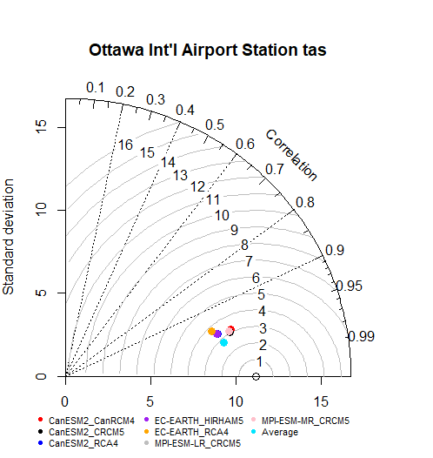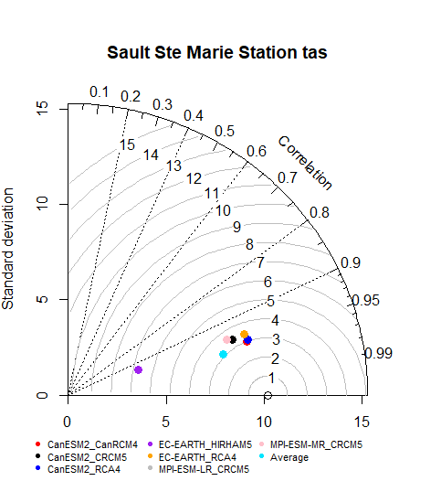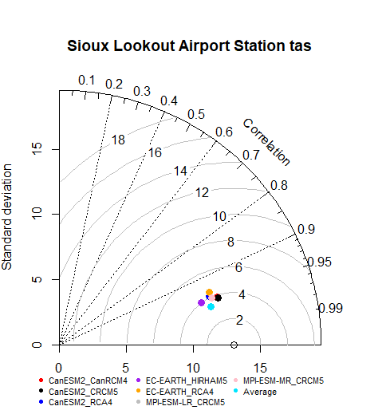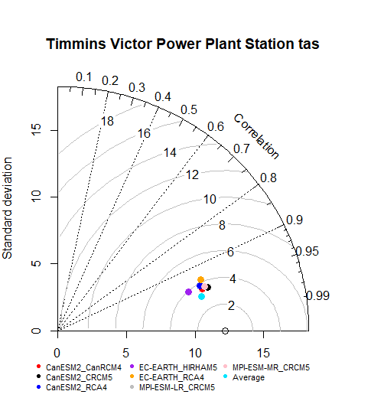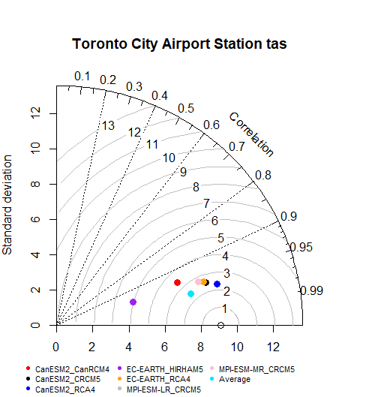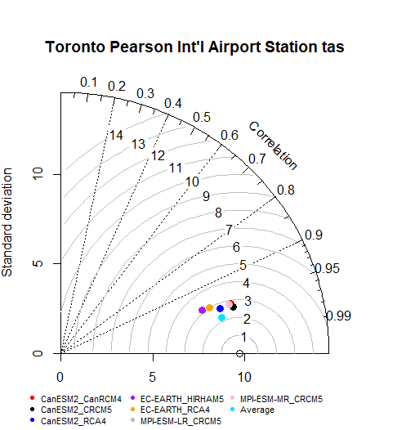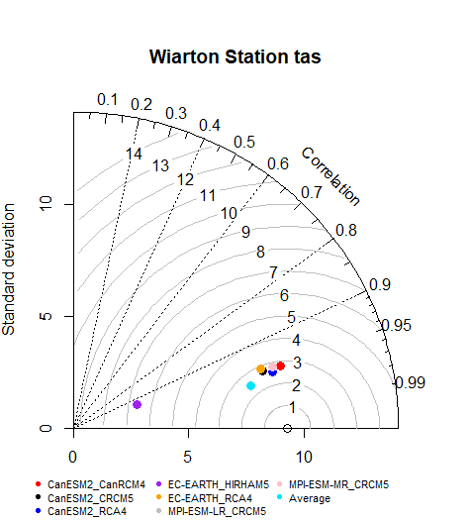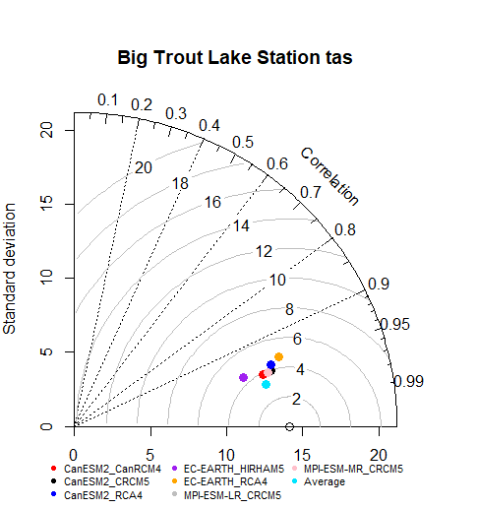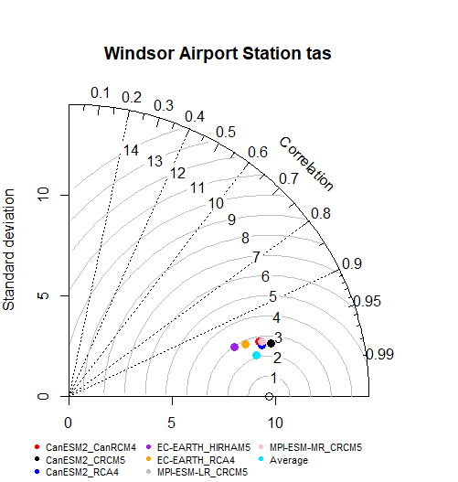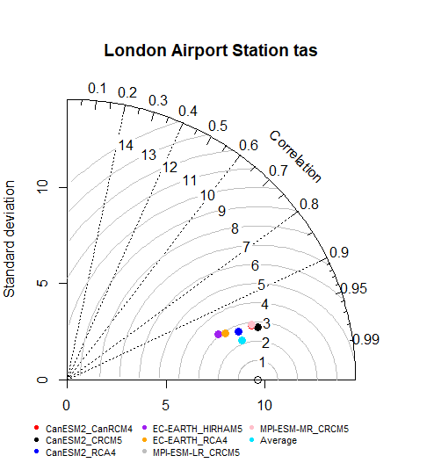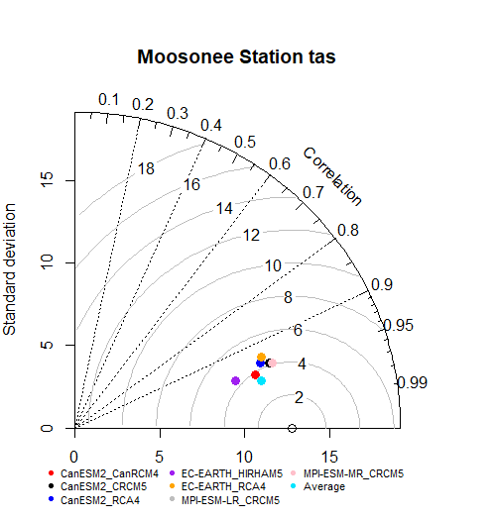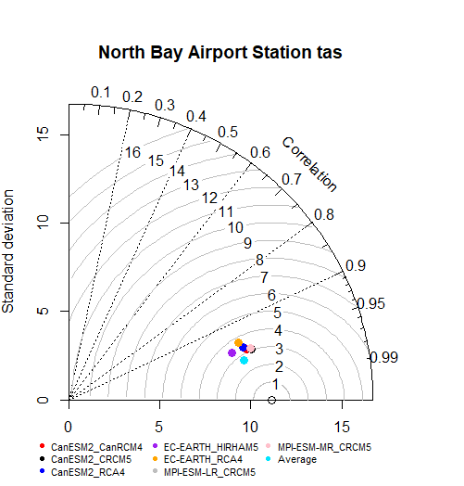

**Fig 3: Taylor Diagrams for 12 Stations - tas**

**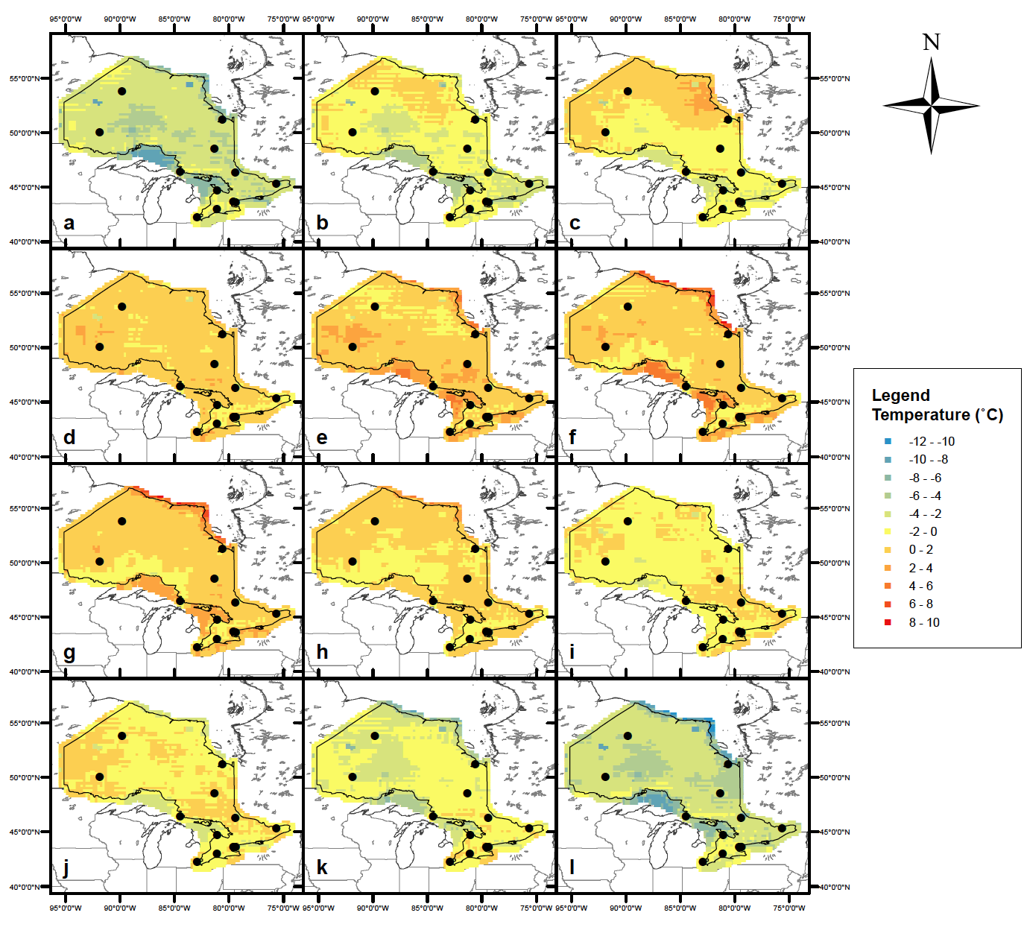**

**Fig 4: Temperature Bias: a) January, b) February, c) March, d) April, e) May, f) June, g) July, h) August, i) September, j) October, k) November, l) December**

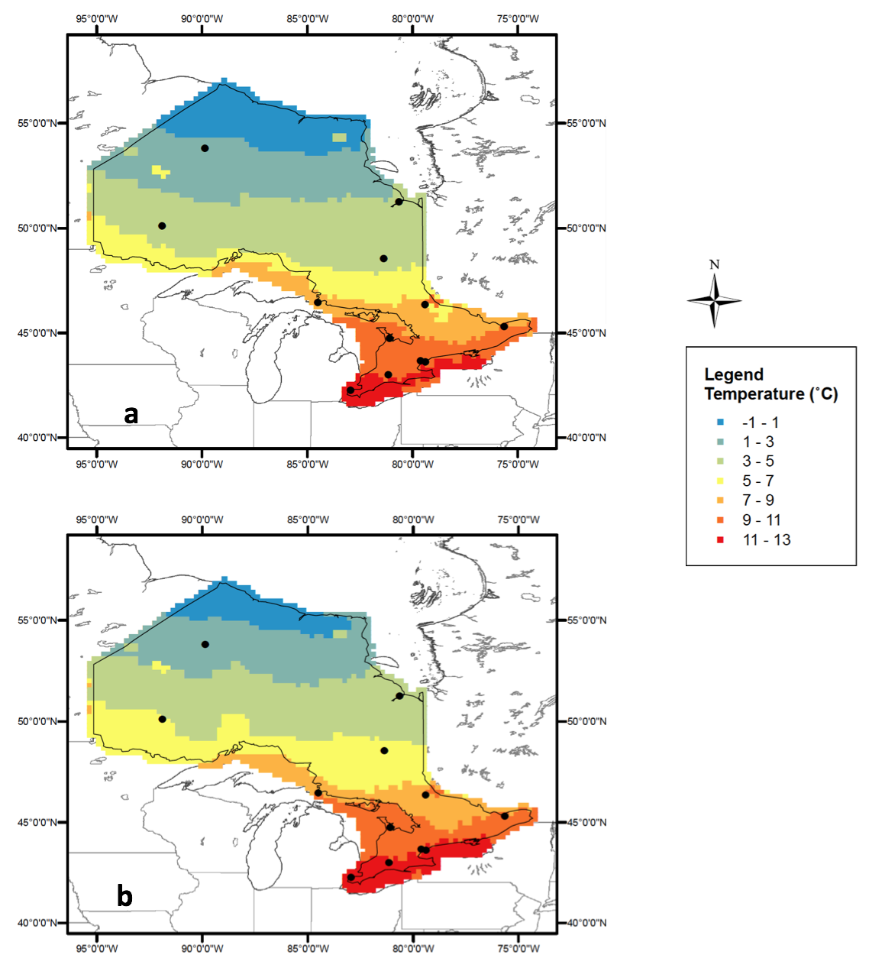

**Fig 5: 30-year annual mean temperature over Ontario under the RCP4.5 scenario: a) 2040 – 2069 and b) 2070 – 2099.**

**Table 1: Twelve Stations Analyzed**

|  |  |  |  |  |  |  |
| --- | --- | --- | --- | --- | --- | --- |
| **No.** | **Station Name** | **Short name** | **Latitude** | **Longitude** | **Elevation** | **Observation Data Time Period** |
| 1 | Windsor Airport | Windsor | 42.28° N | 82.96° W | 189.6 m | 1940-2014 |
| 2 | London International Airport | London | 43.03° N | 81.15° W | 278.0 m | 1940-2006 |
| 3 | Toronto City Center Airport | Toronto City | 43.63° N | 79.40° W | 173.4 m | 1957-2006 |
| 4 | Toronto Pearson International Airport | Toronto Pearson | 43.68° N | 79.63° W | 76.8 m | 1937-2015 |
| 5 | Wiarton Airport | Wiarton | 44.75° N | 81.11° W | 114.0 m | 1947-2014 |
| 6 | Ottawa International Airport | Ottawa | 45.32° N | 75.67° W | 222.2 m | 1938-2011 |
| 7 | North Bay Airport | North Bay | 46.36° N | 79.42° W | 370.3 m | 1939-2014 |
| 8 | Sault Ste Marie Airport | Sault Ste | 46.48° N | 84.51° W | 192.0 m | 1945-2012 |
| 9 | Timmins Victor Power Airport | Timmins | 48.57° N | 81.38° W | 383.4 m | 1955-2011 |
| 10 | Sioux Outlook Airport | Sioux | 50.12° N | 91.90° W | 294.7 m | 1938-2013 |
| 11 | Moosonee | Moosonee | 51.27° N | 80.65° W | 9.1 m | 1932-2006 |
| 12 | Big Trout Lake | Big Trout | 53.83° N | 89.87° W | 224.1 m | 1953-1992 |

**Table 2: GCM and RCM Combinations**

|  |  |  |  |  |
| --- | --- | --- | --- | --- |
| **Scenario** | **GCM** | **RCM** | **Grid** | **Modeling Institution** |
| hist | **CanESM2** | CanRCM4 | 0.44o | CCCma |
|  |  | CRCM5 | 0.44o | UQAM |
| RCA4 | 0.44o | SMHI |
| **EC-EARTH** | HIRHAM5 | 0.44o | DMI |
|  | RCA4 | 0.44o | SMHI |
| **MPI-ESM-LR** | CRCM5 | 0.44o | UQAM |
| **MPI-ESM-MR** | CRCM5 | 0.44o | UQAM |
| RCP4.5 | **CanESM2** | CanRCM4 | 0.44o | CCCma |
|  |  | CRCM5 | 0.44o | UQAM |
| RCA4 | 0.44o | SMHI |
| **EC-EARTH** | HIRHAM5 | 0.44o | DMI |
|  | RCA4 | 0.44o | SMHI |
| **MPI-ESM-LR** | CRCM5 | 0.44o | UQAM |
| **MPI-ESM-MR** | CRCM5 | 0.44o | UQAM |

**Table 3: R2 and RMSE for Toronto Pearson**

|  |  |  |  |  |  |  |  |
| --- | --- | --- | --- | --- | --- | --- | --- |
| **Model** | | **R2** | | | **RMSE** | | |
| **GCM** | **RCM** | **tas** | **tasmax** | **tasmin** | **tas** | **tasmax** | **tasmin** |
| **CanESM2** | **CanRCM4** | 0.92 | 0.92 | 0.89 | 9.95 | 12.77 | 13.20 |
| **CanESM2** | **CRCM5** | 0.93 | 0.93 | 0.91 | 7.84 | 8.58 | 10.13 |
| **CanESM2** | **RCA4** | 0.92 | 0.92 | 0.90 | 12.83 | 10.86 | 21.41 |
| **EC-EARTH** | **HIRHAM5** | 0.91 | 0.91 | 0.90 | 11.64 | 17.81 | 9.80 |
| **EC-EARTH** | **RCA4** | 0.91 | 0.92 | 0.88 | 9.52 | 10.21 | 13.61 |
| **MPI\_ESM\_LR** | **CRCM5** | 0.92 | 0.91 | 0.90 | 10.13 | 12.41 | 9.47 |
| **MPI\_ESM\_MR** | **CRCM5** | 0.92 | 0.91 | 0.90 | 10.13 | 12.41 | 9.47 |
| **Multi-Model Mean Ensemble** | | 0.95 | 0.95 | 0.94 | 4.99 | 5.65 | 6.49 |

**Table 4: p-values - tas**

|  |  |  |  |  |  |  |  |  |  |  |  |  |
| --- | --- | --- | --- | --- | --- | --- | --- | --- | --- | --- | --- | --- |
| **Station** | **January** | **February** | **March** | **April** | **May** | **June** | **July** | **August** | **September** | **October** | **November** | **December** |
| Big Trout | 1.19E-06 | 4.86E-03 | 2.63E-01 | 8.55E-01 | 2.38E-01 | 8.71E-01 | 5.67E-02 | 9.62E-01 | 6.38E-03 | 1.10E-01 | 8.73E-07 | 1.43E-08 |
| London | 2.88E-05 | 1.11E-04 | 3.67E-04 | 4.09E-01 | 7.74E-01 | 1.31E-01 | 1.09E-01 | 2.09E-04 | 6.56E-04 | 2.36E-01 | 4.91E-01 | 5.61E-05 |
| Moosonee | 1.11E-07 | 5.01E-02 | 8.70E-01 | 7.45E-03 | 5.75E-06 | 1.94E-05 | 2.67E-06 | 9.05E-01 | 1.55E-02 | 9.10E-02 | 1.16E-07 | 5.07E-11 |
| North Bay | 1.03E-08 | 2.24E-03 | 4.68E-03 | 2.10E-01 | 1.11E-03 | 3.35E-02 | 6.22E-04 | 5.03E-01 | 5.54E-01 | 4.62E-01 | 1.09E-05 | 1.62E-09 |
| Ottawa | 1.26E-10 | 1.10E-07 | 4.43E-07 | 8.95E-01 | 4.45E-04 | 5.43E-06 | 2.74E-10 | 1.01E-03 | 5.20E-01 | 8.73E-01 | 1.86E-03 | 1.22E-10 |
| Sault Ste | 1.45E-13 | 2.67E-08 | 2.97E-05 | 9.12E-01 | 1.80E-04 | 4.22E-06 | 2.44E-07 | 1.64E-01 | 1.17E-02 | 5.40E-04 | 5.84E-10 | 5.62E-11 |
| Sioux | 7.23E-07 | 4.51E-02 | 6.92E-01 | 4.74E-05 | 4.04E-06 | 3.13E-05 | 5.21E-03 | 6.95E-01 | 9.22E-02 | 8.44E-01 | 1.14E-05 | 4.26E-07 |
| Timmins | 6.90E-08 | 6.06E-03 | 5.96E-01 | 3.34E-02 | 5.90E-05 | 2.78E-04 | 3.74E-06 | 2.35E-01 | 9.93E-01 | 9.85E-01 | 4.36E-05 | 2.16E-08 |
| Toronto City | 2.47E-07 | 2.17E-06 | 1.10E-02 | 1.19E-03 | 1.73E-05 | 8.41E-08 | 1.32E-09 | 4.63E-04 | 9.46E-01 | 6.59E-04 | 9.50E-06 | 1.57E-07 |
| Toronto Pearson | 8.48E-04 | 1.88E-02 | 1.31E-02 | 5.84E-01 | 3.42E-01 | 5.67E-02 | 1.27E-04 | 1.29E-01 | 3.82E-01 | 7.24E-01 | 1.54E-01 | 6.83E-03 |
| Wiarton | 1.98E-12 | 3.23E-10 | 3.29E-08 | 9.14E-01 | 5.12E-02 | 3.39E-02 | 6.53E-03 | 2.45E-01 | 1.90E-03 | 2.07E-04 | 9.82E-08 | 2.95E-12 |
| Windsor | 4.15E-02 | 2.18E-01 | 2.99E-01 | 1.71E-02 | 7.95E-02 | 2.78E-03 | 6.40E-02 | 6.37E-02 | 9.01E-02 | 9.60E-01 | 3.19E-01 | 5.22E-02 |

**Table 5: p-values - tasmax**

|  |  |  |  |  |  |  |  |  |  |  |  |  |
| --- | --- | --- | --- | --- | --- | --- | --- | --- | --- | --- | --- | --- |
| **Station** | **January** | **February** | **March** | **April** | **May** | **June** | **July** | **August** | **September** | **October** | **November** | **December** |
| Big Trout | 3.65E-04 | 7.17E-01 | 2.59E-02 | 1.73E-01 | 7.90E-01 | 6.55E-01 | 3.26E-01 | 1.82E-01 | 2.26E-04 | 9.03E-02 | 3.06E-06 | 1.54E-06 |
| London | 1.96E-04 | 6.00E-05 | 2.58E-05 | 9.53E-01 | 1.25E-01 | 5.96E-01 | 7.10E-01 | 2.04E-03 | 1.79E-01 | 2.24E-01 | 4.17E-01 | 4.13E-03 |
| Moosonee | 3.86E-04 | 1.73E-01 | 1.11E-03 | 1.60E-04 | 1.86E-05 | 3.96E-07 | 9.60E-10 | 6.85E-03 | 5.88E-01 | 9.39E-01 | 1.37E-05 | 4.55E-08 |
| North Bay | 6.16E-08 | 2.46E-03 | 1.33E-02 | 2.75E-02 | 5.81E-07 | 1.01E-04 | 3.59E-05 | 6.03E-01 | 8.09E-01 | 9.45E-01 | 2.52E-04 | 8.97E-08 |
| Ottawa | 2.84E-10 | 1.91E-08 | 1.92E-08 | 3.59E-01 | 1.37E-07 | 6.80E-08 | 9.98E-11 | 3.20E-04 | 9.39E-02 | 1.88E-01 | 3.03E-02 | 6.05E-10 |
| Sault Ste | 6.47E-08 | 1.14E-02 | 4.52E-01 | 5.03E-06 | 2.02E-13 | 1.08E-16 | 2.37E-18 | 7.69E-11 | 2.84E-05 | 2.96E-01 | 3.23E-03 | 1.90E-06 |
| Sioux | 3.60E-03 | 3.68E-01 | 1.35E-04 | 1.53E-09 | 1.56E-10 | 1.27E-08 | 1.08E-04 | 7.62E-01 | 1.80E-01 | 4.48E-01 | 8.61E-04 | 4.00E-04 |
| Timmins | 5.21E-05 | 8.73E-01 | 4.63E-03 | 1.82E-05 | 1.50E-09 | 2.32E-11 | 5.50E-14 | 5.32E-06 | 1.07E-02 | 2.23E-01 | 1.21E-02 | 9.67E-06 |
| Toronto City | 6.56E-05 | 1.48E-04 | 4.95E-02 | 5.48E-05 | 1.46E-08 | 3.53E-11 | 1.44E-13 | 1.55E-07 | 1.30E-02 | 2.04E-01 | 4.67E-02 | 8.78E-05 |
| Toronto Pearson | 2.02E-02 | 4.29E-02 | 3.58E-03 | 2.31E-01 | 2.14E-03 | 3.28E-05 | 8.52E-07 | 2.28E-02 | 1.26E-02 | 1.26E-02 | 3.64E-03 | 3.16E-01 |
| Wiarton | 1.18E-09 | 1.98E-05 | 5.49E-02 | 1.49E-11 | 1.83E-17 | 4.43E-22 | 2.66E-23 | 1.52E-15 | 1.01E-07 | 2.73E-02 | 4.52E-02 | 4.69E-09 |
| Windsor | 1.58E-01 | 1.75E-01 | 4.50E-01 | 8.25E-06 | 6.14E-05 | 4.71E-08 | 9.32E-04 | 3.17E-01 | 4.76E-01 | 1.25E-02 | 2.91E-03 | 6.00E-01 |

**Table 6: p-values - tasmin**

|  |  |  |  |  |  |  |  |  |  |  |  |  |
| --- | --- | --- | --- | --- | --- | --- | --- | --- | --- | --- | --- | --- |
| **Station** | **January** | **February** | **March** | **April** | **May** | **June** | **July** | **August** | **September** | **October** | **November** | **December** |
| Big Trout | 1.78E-10 | 1.42E-08 | 1.75E-06 | 3.91E-03 | 5.85E-05 | 1.22E-02 | 8.91E-01 | 6.29E-02 | 4.23E-05 | 9.96E-04 | 8.90E-08 | 5.37E-11 |
| London | 8.81E-06 | 1.87E-04 | 2.36E-05 | 5.01E-05 | 2.47E-04 | 1.03E-06 | 8.76E-07 | 4.88E-10 | 2.82E-13 | 1.11E-10 | 3.75E-06 | 3.52E-07 |
| Moosonee | 8.65E-11 | 1.79E-06 | 3.98E-03 | 6.30E-01 | 9.88E-02 | 8.43E-01 | 1.02E-01 | 1.60E-07 | 2.22E-09 | 4.73E-07 | 6.65E-09 | 8.49E-13 |
| North Bay | 3.65E-10 | 6.74E-05 | 4.74E-05 | 3.49E-02 | 5.26E-01 | 2.25E-01 | 8.51E-01 | 8.99E-02 | 1.49E-04 | 3.36E-05 | 5.76E-09 | 4.15E-11 |
| Ottawa | 1.33E-11 | 2.01E-08 | 3.32E-08 | 3.22E-05 | 5.25E-01 | 3.26E-01 | 4.87E-03 | 4.29E-01 | 3.26E-05 | 6.30E-07 | 1.26E-08 | 7.43E-12 |
| Sault Ste | 6.78E-17 | 7.34E-13 | 3.79E-12 | 1.33E-10 | 3.20E-09 | 1.79E-09 | 1.13E-09 | 9.35E-12 | 4.66E-17 | 1.85E-13 | 3.72E-17 | 8.24E-14 |
| Sioux | 3.17E-12 | 6.15E-07 | 2.51E-04 | 1.40E-01 | 3.45E-01 | 3.44E-01 | 1.26E-02 | 2.70E-04 | 2.48E-08 | 8.56E-04 | 9.00E-09 | 8.90E-11 |
| Timmins | 4.46E-11 | 7.96E-08 | 6.31E-05 | 9.29E-03 | 7.03E-02 | 9.56E-05 | 2.59E-06 | 7.65E-09 | 4.75E-09 | 1.37E-05 | 2.67E-08 | 1.43E-10 |
| Toronto City | 3.37E-09 | 2.25E-08 | 1.01E-05 | 2.22E-02 | 3.86E-01 | 6.68E-01 | 6.81E-01 | 4.29E-01 | 1.45E-05 | 4.23E-09 | 7.54E-11 | 1.37E-09 |
| Toronto Pearson | 2.44E-05 | 1.79E-03 | 2.33E-04 | 7.95E-04 | 7.44E-04 | 7.14E-03 | 2.87E-01 | 1.90E-02 | 1.03E-05 | 2.83E-07 | 9.41E-04 | 1.54E-05 |
| Wiarton | 1.16E-19 | 7.04E-18 | 7.27E-17 | 3.32E-15 | 4.27E-13 | 1.97E-15 | 1.14E-16 | 1.13E-20 | 4.00E-25 | 4.78E-24 | 1.34E-24 | 1.61E-20 |
| Windsor | 1.39E-03 | 1.48E-02 | 1.13E-04 | 5.34E-06 | 3.16E-04 | 1.32E-04 | 3.42E-05 | 4.17E-08 | 6.23E-13 | 1.17E-08 | 3.64E-05 | 1.26E-04 |

**Table 7: Hist R2 values across the whole domain of Ontario, Canada.**

|  |  |  |  |  |  |  |  |  |  |  |
| --- | --- | --- | --- | --- | --- | --- | --- | --- | --- | --- |
| **Model** | | **R2** | | | | **RMSE** | | | |  |
| **GCM** | **RCM** | | ***tas*** | ***tasmax*** | ***tasmin*** | | ***tas*** | ***tasmax*** | ***tasmin*** | |
| **CanESM2** | **CanRCM4** | | 0.945 | 0.946 | 0.928 | | 16.339 | 13.321 | 28.020 | |
| **CanESM2** | **CRCM5** | | 0.977 | 0.969 | 0.963 | | 6.735 | 5.679 | 15.253 | |
| **CanESM2** | **RCA4** | | 0.967 | 0.963 | 0.946 | | 9.997 | 8.374 | 21.100 | |
| **EC-EARTH** | **HIRHAM5** | | 0.958 | 0.940 | 0.963 | | 12.190 | 19.963 | 15.117 | |
| **EC-EARTH** | **RCA4** | | 0.953 | 0.950 | 0.933 | | 7.678 | 8.718 | 12.217 | |
| **MPI-ESM-LR** | **CRCM5** | | 0.982 | 0.974 | 0.970 | | 3.772 | 8.341 | 5.477 | |
| **MPI-ESM-MR** | **CRCM5** | | 0.982 | 0.974 | 0.970 | | 3.772 | 8.341 | 5.477 | |
| **Multi-Model Mean Ensemble** | | | 0.983 | 0.977 | 0.975 | | 4.108 | 4.511 | 9.753 | |

# List of Tables

Table 1: Twelve Stations Analyzed 15

Table 2: GCM and RCM Combinations 16

Table 3: R2 and RMSE for Toronto Pearson 17

Table 4: p-values - tas 18

Table 5: p-values - tasmax 19

Table 6: p-values - tasmin 20

Table 7: Hist R2 values across the whole domain of Ontario, Canada. 21

# Table of Figures

Fig 1: Location of the Twelve Selected Stations 8

Fig 2: Annual Temperature Variation at Each Station 9

Fig 3: Taylor Diagrams for 12 Stations - tas 10

Fig 4: Temperature Bias: a) January, b) February, c) March, d) April, e) May, f) June, g) July, h) August, i) September, j) October, k) November, l) December 11

Fig 5: 30-year annual mean temperature over Ontario under the RCP4.5 scenario: a) 2040 – 2069 and b) 2070 – 2099. 12

**References:**

Chai T, Draxler RR (2014) Root mean square error (RMSE) or mean absolute error (MAE)? - Arguments against avoiding RMSE in the literature Geosci Model Dev 7:1247-1250 doi:10.5194/gmd-7-1247-2014

Dasari HP, Salgado R, Perdigao J, Challa VS (2014) A regional climate simulation study using WRF-ARW model over Europe and evaluation for extreme temperature weather events International Journal of Atmospheric Sciences 2014

Demerse C (2016) Ignoring climate change will cost us too, big time.

Environment OMot (2011) Climate Ready: Ontario's Adaptation Strategy and Action Plan 2011-2014. Ontario Ministry of the Environment,

Giorgi F, Jones C, Asrar GR (2009) Addressing climate information needs at the regional level: the CORDEX framework World Meteorological Organization (WMO) Bulletin 58:175

Gizaw MS, Gan TY (2017) Impact of climate change and El Niño episodes on droughts in sub-Saharan Africa Clim Dynam 49:665-682

Hagedorn R, Doblas-Reyes FJ, Palmer TN (2005) The rationale behind the success of multi-model ensembles in seasonal forecasting - I. Basic concept Tellus Ser A-Dyn Meteorol Oceanol 57:219-233 doi:10.1111/j.1600-0870.2005.00103.x

Harris I, Jones PD, Osborn TJ, Lister DH (2014) Updated high-resolution grids of monthly climatic observations - the CRU TS3.10 Dataset Int J Climatol 34:623-642 doi:10.1002/joc.3711

Katz RW (1992) Role of statistics in the validation of general circulation models Climate Research:35-45

Kirtman BP, Min D (2009) Multimodel Ensemble ENSO Prediction with CCSM and CFS Mon Weather Rev 137:2908-2930

Lamarque JF et al. (2010) Historical (1850-2000) gridded anthropogenic and biomass burning emissions of reactive gases and aerosols: methodology and application Atmos Chem Phys 10:7017-7039 doi:10.5194/acp-10-7017-2010

Laprise R et al. (2013) Climate projections over CORDEX Africa domain using the fifth-generation Canadian Regional Climate Model (CRCM5) Clim Dynam 41:3219-3246 doi:10.1007/s00382-012-1651-2

Lee JY, Wang B (2014) Future change of global monsoon in the CMIP5 Clim Dynam 42:101-119 doi:10.1007/s00382-012-1564-0

Li Z, Huang G, Wang X, Han J, Fan Y (2016) Impacts of future climate change on river discharge based on hydrological inference: A case study of the Grand River Watershed in Ontario, Canada Science of The Total Environment 548:198-210

Lucas-Picher P, Somot S, Deque M, Decharme B, Alias A (2013) Evaluation of the regional climate model ALADIN to simulate the climate over North America in the CORDEX framework Clim Dynam 41:1117-1137 doi:10.1007/s00382-012-1613-8

Mezghani A et al. (2017) CHASE-PL Climate Projection dataset over Poland – Bias adjustment of EURO-CORDEX simulations Earth Syst Sci Data Discuss 2017:1-29 doi:10.5194/essd-2017-51

Nagelkerke NJD (1991) A Note on a General Definition of the Coefficient of Determination Biometrika 78:691-692 doi:DOI 10.1093/biomet/78.3.691

Palmer TN, Doblas-Reyes FJ, Hagedorn R, Weisheimer A (2005) Probabilistic prediction of climate using multi-model ensembles: from basics to applications Philos T R Soc B 360:1991-1998

Perera AH, Euler D, Thompson ID, Ontario. Ministry of Natural Resources., desLibris - Books, eBrary (Canadian Publishers Collection) (2000) Ecology of a managed terrestrial landscape : patterns and processes of forest landscapes in Ontario. Published by UBC Press in cooperation with the Ontario Ministry of Natural Resources, Vancouver

Ragone F, Lucarini V, Lunkeit F (2016) A new framework for climate sensitivity and prediction: a modelling perspective Clim Dynam 46:1459-1471 doi:10.1007/s00382-015-2657-3

Rotstayn LD, Jeffrey SJ, Collier MA, Dravitzki SM, Hirst AC, Syktus JI, Wong KK (2012) Aerosol- and greenhouse gas-induced changes in summer rainfall and circulation in the Australasian region: a study using single-forcing climate simulations Atmos Chem Phys 12:6377-6404 doi:10.5194/acp-12-6377-2012

Solomon S, D. Qin, M. Manning, Z. Chen, M. Marquis, K.B. Averyt, M.Tignor and H.L. Miller (eds.) (2007) IPCC, 2007: Climate Change 2007: The Physical Science Basis. Contribution of Working Group I to the Fourth Assessment Report of the Intergovernmental Panel on Climate Change

Taylor KE (2001) Summarizing multiple aspects of model performance in a single diagram. J Geophys Res-Atmos 106:7183-7192 doi:Doi 10.1029/2000jd900719

Tebaldi C, Knutti R (2007) The use of the multi-model ensemble in probabilistic climate projections Philos T R Soc A 365:2053-2075 doi:10.1098/rsta.2007.2076

Thomson AM et al. (2011) RCP4. 5: a pathway for stabilization of radiative forcing by 2100 Climatic change 109:77

Wang X et al. (2013) A stepwise cluster analysis approach for downscaled climate projection–A Canadian case study Environmental modelling & software 49:141-151

Wang XQ, Huang GH, Lin QG, Nie XH, Liu JL (2015) High-resolution temperature and precipitation projections over Ontario, Canada: a coupled dynamical-statistical approach Q J Roy Meteor Soc 141:1137-1146

Weigel AP, Knutti R, Liniger MA, Appenzeller C (2010) Risks of Model Weighting in Multimodel Climate Projections J Climate 23:4175-4191 doi:10.1175/2010jcli3594.1

Wotton B, Martell D, Logan K (2003) Climate change and people-caused forest fire occurrence in Ontario Climatic Change 60:275-295

Xue PF, Pal JS, Ye XY, Lenters JD, Huang CF, Chu PY (2017) Improving the Simulation of Large Lakes in Regional Climate Modeling: Two-Way Lake-Atmosphere Coupling with a 3D Hydrodynamic Model of the Great Lakes J Climate 30:1605-1627 doi:10.1175/Jcli-D-16-0225.1